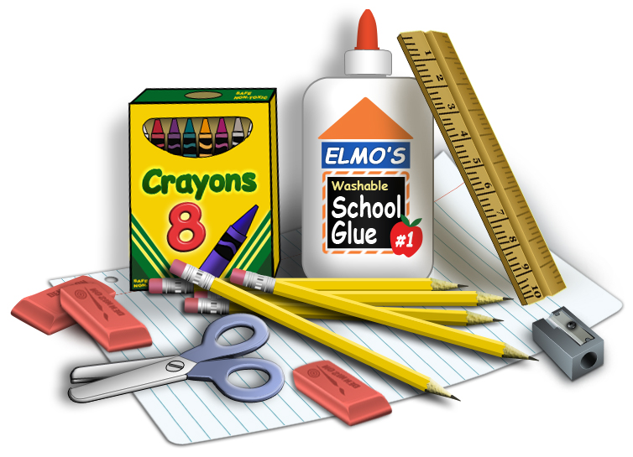

UMCOR SCHOOL KITS:

The back-to-school sales have begun so it's time to collect items for UMCOR kits. These school kits will be sent all over the world, including in the U.S., to students living in poverty or areas devastated by natural disasters. A pencil, notebook or box of colors seems so simple to us but to a student without these basic learning tools, it can mean all the difference in the world. Please take advantage of the great sales going on right now and purchase several items for the school kits and put them in the collection box by the food pantry table. Each Kit contains the following items:
- 1 scissor (blunt tips please)
- 3 spiral notebooks (narrow or wide ruled)
- 1 twelve inch ruler
- 1 hand held pencil sharpener
- 6 unsharpened pencils with erasers
- 1 eraser 2 1/2 inches
- 1 box of 24 crayons (24 only)

